All lessons are suspended, and emergency childcare will be provided.

Dear parent,

The National Security Council has decided to suspend all lessons in all schools in order to prevent the further spread of the coronavirus and to protect vulnerable groups.

When?
From midnight on Friday 13th March until Friday 3rd April 2020

What do you need to do?
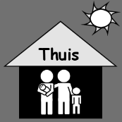
Children who are ill or who have symptoms of the coronavirus (such as a sore throat, headache, fever, cough, flu-like sensation) need to stay at home. Call your family doctor. Do not go to the emergency department or the doctor’s surgery.

Is your child healthy, but you are unable to stay home? Look for childcare, but be considerate towards vulnerable groups (no grandparents or people with ill health).

Make sure to respect the guidelines on personal hygiene in your own home as well. See https://www.infocoronavirus.be/en/

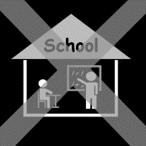
What does the school do?

Lessons are suspended. Emergency childcare will be offered to all pupils for which parents were unable to find childcare.

When organising childcare, we will consider hygiene, distance, ventilation … as well as respecting the prevention measures.

Questions?
- Contact the school on <TELNUMMER school>
- Call the hotline on 0800 14689 or the hotline of Antwerp city (03 22 11 333)
- Visit https://onderwijs.vlaanderen.be/nl/coronavirus-voor-ouders for more information

We will keep you informed of any extra guidelines by email. Therefore, please check your mailbox on a regular basis. Thank you for your understanding!

